**Identifying Types of Intracranial Hemorrhage**

Cristina Giraldo

Taisha Ferguson

George Washington University

Table of Contents

**Chapter 1: Introduction** 3

**Chapter 2: Data** 4

**Summary of dataset** 4

**S.m.a.r.t. Question** 4

**Chapter 3: Methods** 5

**Encoding** 5

**Chapter 4: Results** 5

**Chapter 5: Summary and Conclusions** 5

**Reference** 5

# **Chapter 1: Introduction**

According to Cleveland Clinic, intracranial hemorrhage is a condition where some type of bleeding occurs inside of the skeletal structure of the head. This bleeding is caused by a rupture of a vessel in the brain which can interrupt the flow of oxygen and cause brain damage. If the condition is not treated promptly and the type of the hemorrhage is problematic the brain can die. The main purpose of this project is to identify different types of intracranial hemorrhages that could occur in the brain, such as: intraparenchymal, intraventricular, subarachnoid, subdural and epidural.

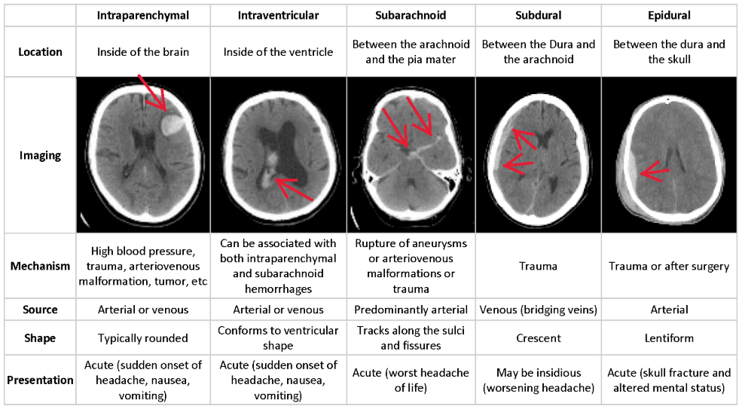

# **Chapter 2: Data**

## **Summary of dataset**

The data used for this project is a collection of computed tomography of the brain. The dataset lists about 5 million of medical images with different types of intracranial hemorrhage (intraparenchymal, intraventricular, subarachnoid, subdural and epidural). The dataset is divided in training and test set.

## **S.m.a.r.t. Question**

Is it possible to identify a type of hemorrhage from an image and obtain a good accuracy in the prediction? The purpose of this analysis is to determine whether the system can identify an intracranial hemorrhage in a computed tomography with precision to ease the job of a radiologist.

# **Chapter 3: Methods**

The analysis conducted in this report is based on computed tomography images captured

## **Encoding**

# **Chapter 4: Results**

By using first

# **Chapter 5: Summary and Conclusions**

Our project used

# **Reference**

García, S., Luengo, J., & Herrera, F. (2015). Data preprocessing in data mining. Cham: Springer.

<https://nlp.stanford.edu/IR-book/html/htmledition/stemming-and-lemmatization-1.html>

A. N. (n.d.). *Support Vector Machines*. Lecture

<http://cs229.stanford.edu/notes/cs229-notes3.pdf>

Jain, S. (2019, March 11). Ultimate guide to deal with Text Data (using Python) - for Data Scientists and Engineers. Retrieved from <https://www.analyticsvidhya.com/blog/2018/02/the-different-methods-deal-text-data-predictive-python/>

R. (n.d.). *An Idiot’s guide to Support vector machines (SVMs)*. Lecture.

Text Analytics for Beginners using NLTK. (n.d.). Retrieved from <https://www.datacamp.com/community/tutorials/text-analytics-beginners-nltk>

Tibshirani, R. (1996) Regression shrinkage and selection via the lasso. J.R.S.S.B. 58, 267-288

A. (2016, February 24). *Topics in sparse Support Vector Machines*. University of Arizona.

<https://www.math.arizona.edu/~wammonj/talks/topics-sparse-svms.pdf>

J., S., T., & R. (n.d.). *1-norm Support Vector Machines*. Stanford University

<https://papers.nips.cc/paper/2450-1-norm-support-vector-machines.pdf>